2022 Financial Report
Balance on January 1, 2022, $44,410.43
Total 2022 Income $31,222.66
Total 2022 Expenses $24,616.24
Balance on December 31, 2022, $51,016.85
All the books are balanced with the PNC Bank statement as of December 31, 2022.
The following chart shows the distribution of expenditures during 2022.
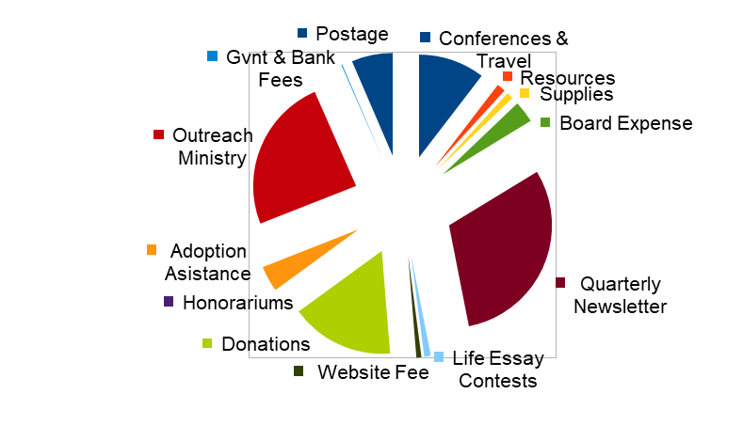
We praise and thank the Lord of life for your generous donations. Your gifts enable us to carry out our mission in Michigan churches, schools, and communities, to give witness to the sanctity of all human life, from fertilization until forever, based upon the Word of God. And they allow us to provide most resources free of charge.
Income for 2022 was at an all-time high! We are pleased that we have been able to continue to provide financial support to several pregnancy resource centers around the state. We also supported two projects that obtained matching fund grants from the Lutheran Church Missouri Synod Life Ministry Million Dollar Life Match grant program. We would be pleased to discuss aiding and providing seed money to help start a Life Team at your congregation, or to help your Life Team progress to the next step. We would also like to discuss assisting your congregation in hosting a Life Issues event.
Memorials or Honorary Gifts

The enclosed gift is in memory of
OR
The enclosed gift is in honor of

Please send notification of this gift to:

Name

Address:

City, State, Zip

Your name

Donations to National Lutherans For Life
The “I WANT TO SPEAK FOR LIFE” form provided is used to give a donation to National Lutherans For Life in Nevada, IA. When using that form you need to provide your own envelope and mail it to address shown on the bottom of the form. Lutherans for Life of Michigan is part of Lutherans For Life but we have separate budgets and bank accounts. The National office has paid staff members but Lutherans For Life of Michigan has no paid staff. National sponsors conferences and develops resources to be used throughout the United States and other countries. LFL of MI provides educational information and sponsors events and conferences in Michigan churches, schools, and communities.

